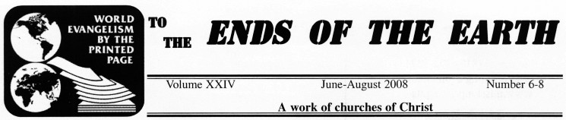
Mission Printing, Inc.  address  2707 Medlin Dr.  Arlington, TX 76015  missionprinting@gmail.com  www.missionprinting.us  Board of Trustees  Tom Garner, President  Doug Jarvis, Secretary  Roy Thomas, Treasurer  Darrell Allen  Calvin Hammons  Richard Renfro  Tom Sarratt, Jr.  Director  Vendall W. Dollarhide  cell 817-504-1834  dollarhidefamily@juno.com  Office Administrators  Mary Carroll  department communication, mail volunteer supervisor, newsletter, email,  shipping, etc.  Jessie Lee Caskey  promotion  Alice Walker  bookkeeping, call center,  proofing, etc.  VOLUNTEERS ARE  WELCOMED!  Monday-Thursday  7:00 AM-2:00 PM |  | Personal Visits from  Ghana and Nigeria
  Mission Printing has been blessed recently with personal visits from three gospel preachers from Ghana and Nigeria. It was so uplifting to hear them tell of the need for Mission Printing material. The books are in great demand. If one is found along the road, it is picked up and read and then passed along to others to read. Willie Gley, Ghana preacher, told us if he had all the material we had in stock, he would be out in three months.  Sylvester Imogoh and Monday John Akapakpan, Nigerian preachers, came with Dough Wheeler of Norman, OK. They told Brother Wheeler that they wanted to visit Mission Printing. They took pictures and visited with volunteers so that they could share the Mission Printing story with others and personally relate how helpful the materials are to their work. They also wanted the people of Nigeria to see the work of Mission Printing.  It made us aware of how important our work at Mission Printing is for spreading the Word of God. The preachers from Nigeria referred to our workers as “Paper Missionaries.” | 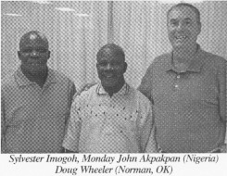  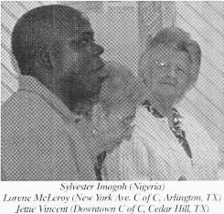
  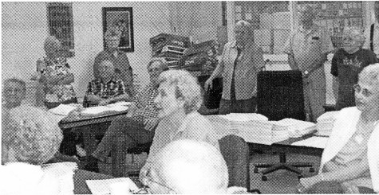
  Visits from our brothers in Nigeria and Ghana help to remind us why Mission Printing exists: “World Evangelism!” These visits gave us a renewed sense of purpose and excitement.
  All of our volunteers find great joy in knowing that lost souls are being touched by Christ through their efforts at Mission Printing. This is why we are a part of the Mission Printing family and why we all can rejoice.!

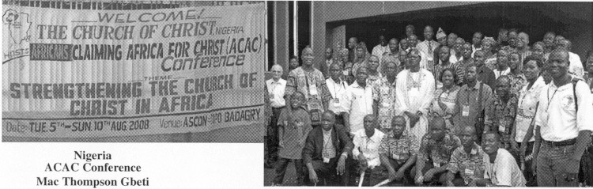
The Africans Claiming Africa for Christ conference is organized by churches of Christ in Africa in collaboration with local congregations and former missionaries to Africa. It has the primary aim of actively involving Africans in the evangelization of their own continent. The conference also meets to review evangelism efforts across Africa enabling ministers to compare notes and share insights for greater exploits aimed at extending the frontiers of the Lord’s kingdom across the continent.  ACAC provides a forum for cross-cultural interaction among Christians from other parts of Africa. It affords the participants an opportunity to know the activities and impact of the church in other African countries. It also reveals areas in the continent where the church is not in existence, and strategies are put in place to effectively reach these areas with the gospel.  The conference rotates from one African country to another in intervals of four years. The next one will be in 2012 in Zambia.  This year’s conference was attended by more than 800 participants from the following nations: Angola, Benin, Cameroon, Equatorial Guinea, Ghana, Kenya, Liberia, Mali, Namibia, Nigeria, Rwanda, Senegal, South Africa, Togo, United States, Zambia, and Zimbabwe.  Mission Printing has been happily sending material to the attendees of the ACAC conference for many years. Mission Printing is dedicated to the work throughout Africa. | 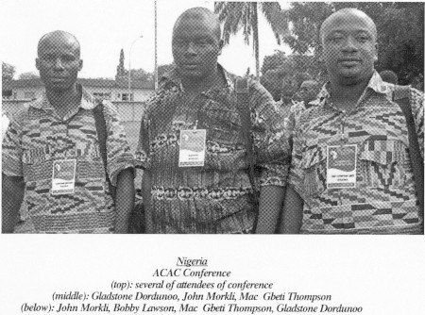  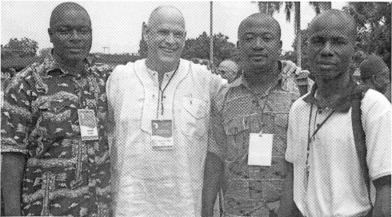
Coldwater, MI  Betty Taylor  The harvest of souls is so needed and the printed page is a great tool. Please reach more with this offering.  Asankrangwa, Ghana  Abraham Arbin  It is my prayer that you will one day come and witness the amazing spiritual fruit that your material has helped to grow. Mission Printing has helped us to convert many souls to the Lord!  Many people have shown interest in your books and a great number of congregations have ordered Mission Printing material from us. Our supply is low, so we are requesting more your scripturally sound studies!  Port Blair, Andaman Island, India  Andaman Island Church of Christ  Paul Joshua  I have been doing the Lord’s work on this island for three years. When I first came here, there were not churches of Christ. Now we have more than 20 gathering every Sunday. Please continue to pray for our work.  I recently received one of Mission Printing’s books and I was very impressed. I have studied and found your material very useful for my spiritual life and for those that want to teach the lost. Therefore, we humbly request that you send us material so that we can proclaim the Truth to the lost and to mature the saved.  Ikot Ekpene, Akwa Ibom State, Nigeria  Victor Udohabasi  We are praying for God to bless Mission Printing abundantly. May He also continue to proved the much needed funding to keep this vital work functioning.  Buwenge, Uganda  Kagoma Church of Christ  Wandera Paul  Thank you Mission Printing for the great work that you are doing and for sending the “printed page” to us. In fact, I do not have the words to express how helpful Mission Printing is to Uganda!  With your material, we have been able to establish three new congregations. We were able to raise funds recently to run a radio program for one hour. We used the Mission Printing books as aids in the program and the response was amazing! |  | Kumba Meme, Cameroon  Queen Nursery  It was with great joy that we received the 4 bags of books from Mission Printing! Thank you so much. These books will help us to train our children with the knowledge of the Lord, so that they will not depart when they are old.  Benin City, Edo State, Nigeria  Abraham Mecharu  I wanted to thank you all for the excellent material which Mission Printing has been sending me for our evangelism work. The material has helped me so much in my present area of ministry. You were even helping me to plan the seed when I was working in Asaba in the Delta State. All of the books which Mission Printing has sent me over the years has aided my ministry and motivated me to continue working in the harvest field.  Agbado Station, Ogun State, Nigeria  I am very happy because of the scripturally sound literature that you sent to me. God has changed many people’s souls through Mission Printing’s ministry.  We use the children’s material to teach our children’s classes.  We hold crusades in various locations and we use Mission Printing’s material to plant the truth even deeper.  We are asking you to help us supply Bibles to our new converts in the village. We try to give the new converts a Bible and some of Mission Printing’s books.  Ogun State, Nigeria  We are very happy to receive your material. In fact, God has changed many people using your books as a starting point for a more in depth Bible study. We use the “Jesus Loves Us” series to teach our children.  We are an evangelistic church and we are constantly holding gospel crusades in area villages.  We would like to request some Bibles for our new converts. We try to give them a Bible and some Mission Printing books to help them continue to mature.  “I do not have the words to express how helpful Mission Printing is to Uganda!” |  | Ogbete, Enugu State, Nigeria  Herbert Nwankwo Chukwu  One of the methods that we are using to spread the gospel of Jesus Christ is tracts. We used to receive your material. Many congregations would collect the wonderful tracts from us and then use in their own work. Because of the popularity of your material, our supply has grown low.  I want to use this letter to request more tracts. The Mission Printing material is very important and helpful in our gospel meetings; and since many congregations come to us for material, we are asking that you send us a large number of tracts.  “Thank you for the great work you do for Christ!”  Olongapo City, Philippines  Michael A. Alop  I’m the pulpit preacher with the Kalaklan Church of Christ. I’m also actively (as Provincial Coordinator) helping WBS teach God’s word through correspondence courses. I just want to inform you that I received the 2 boxes of material from you. It was with much JOY in my heart that I received this unexpected gift. Thank you very much!  One congregation in our area has already benefited from the material. I have given one box to the Cabalan Church of Christ to help in their ministry. You should have seen the smile on their faces. You guys are incredible.  Bvumbwe, Thyolo, Malawi  Kalimbuka Church of Christ Magomero Jairos Banda  I was trained by the Bible college in Muzu for two years. One day I was invited to a gospel meeting, which was held in the northern region of Malawi. My tope was “Duties of Women in the Church.”  At the gospel meeting, I me a preacher who was distributing different books to the attendees. Unfortunately, he ran out before he got to me. I was curious about the books so I did a search for the titles and discovered Mission Printing. Praise God!  Can you please send me books, written by Guy Caskey and other great writers from the brotherhood. The Mission Printing material will help to promote the work in areas where I am not able to visit as often as others.  Thank you for the great work you do for Christ!

Baguio City, Philippines
Midtown Church of Christ
Jonathan “JoJo” Ramos
I truly thank God for brethren like you. Mission Printing has been a great blessing to us, especially here in the mountainous region of the Philippines.  The Lord’s work through your material is doing great!  Your songbook is a great help for us. We received it at the perfect time. Mission Printing’s songbooks are easier to carry from house to house and village to village. We’ve distributed them to care groups, congregations, a missionary training school, and some brethren who facilitate Bible studies. We hope you can increase the supply of the songbooks. We use them with our young congregations, our evangelism work, home devotionals, and Bible studies.  Michael Alop from Olongapo City, a former US base |  | command and a city similar to Las Vegas, wanted me to relay his request for your material. Olongapo City is a place of much sin and poverty, so Brother Alop could truly use Mission Printing’s material. I will be trying to give him 2 boxes of Mission Printing material to get him through this time, until you can send him more.  I wanted to take this time to request more Mission Printing material. Our stocks are now diminished. We have fabricated a rack for your material in our church building for our brethren and its being used by many for their personal study and in their personal evangelism.  From the bottom of my heart, I truly thank God for Mission Printing and your willingness to be united with us in the work of the Lord. Your gifts have been a great blessing to us!

Limbe, Malawi  Wotutu Church of Christ  Elangwe Magdalene  Our preacher’s wife is requesting Mission Printing material that she can use to teach the sisters in the church. She is begging you to send some material related to her plea!  “You guys are incredible!”  Glenwood, Arkansas  Neil S. Edmundson  Greeting to all of you at Mission Printing. I am aware that Mission Printing does a great and profitable work.  I do WBS and have received requests for lessons from about 13,000 people since 1987. I have used Mission Printing lessons and they have been very helpful. I have received 214 requests from Malawi this week. I am 94 years old now and not able to do the work myself (I am in good health for someone my age!). Others help me to take care of all the requests.  I do very much appreciate the newsletter “To the ends of the Earth” and would like to continue to receive it. I would also like to have a complete set of Mission Printing material for local evangelism as used by the Sycamore Church of Christ in Cooksville, TN. | Kumba, Cameroon  Ngah William  The gospel books which you sent are meeting the spiritual need of many brethren in Cameroon. We are using the material in our Bible classes for adults and children. We are also using them in our house to house evangelism. The result is great and positive!  We are hoping to have a seminar in September and another one in February 2009. We plan to hand out more of Mission Printing’s material to the congregations that attend.  So far, we have baptized 17 souls as a result of people reading your material, studying the Bible, and follow-up work.  May God continue to bless Mission Printing, all the volunteers, and the readers of all the material.  Alexandria, VA  Chidi Ugwunna  First and foremost, I would like to thank you very much for the books. I am forever grateful because these books are free of charge and are SOUND in doctrine. That’s why I would recommend the Mission Printing material to any brother or sister as a resource from which to teach and preach about Jesus Christ and His love for us.  Once again, thank you. I am planning to hand out these tracts to souls who need Jesus Christ. |  |  |  | Takoradi, Ghana  Funkoe Church of Christ  West Coast School of Preaching  Joseph Eshun  Thank you for the wonderful booklets you sent us. The Mission Printing material really does aid in our evangelism work.  I wanted to write you and share how we use your material. First, we encourage our members to carry several of the books in their handbags. When they meet people on the streets, they distribute the books, which often opens the door for further contact. We often get invited to homes of people to which we have given the Mission Printing books.  Secondly, when I visit other congregations, I share the material with them and ask if I can speak to the entire congregation. They are excited to hear that Mission Printing is there to help them also!  Finally we have established a resource library. We encourage people to come and get one of the books. After reading the book, we ask them to bring it back and get another one. This allows us to open the door and see if they have any questions regarding what they have read.  Truly, your material is helping to spread God’s message to the world, especially in Ghana. I am humbly requesting that you send us more books so that we can begin handing them out on the buses in our community. Your help and prayers are proudly welcomed!

Mission Printing has been blessed once again this summer with visits from young people. I am honored to know each young person that chooses to come to Mission Printing. They are a part of something amazing: the Mission Printing family!  God is at work in the next generation! Never let the world or Satan convince you that the next generations are hopeless and that we should give up on them. The young people that come to Mission |  |  |  | Printing are willing to work, learn from those around them, and fellowship with Christians a “few” years older than themselves.  If you know any of these young people, please give them a hug and an encouraging word. Each of these precious souls is a true asset to the kingdom and the future of Mission Printing.
College Hill Church of Christ (N. Richland Hills, TX)  Edith Angeles (16)  Ivett Angeles (16)  Handley Church of Christ (Fort Worth, TX)  Jeremiah Johnson (16) |  |  |  | Legacy Church of Christ (N. Richland Hills, TX)  Jonathan Sanford (8)  Kristen Sanford (12)  Northeast Church of Christ (Paris, TX)  Rudy Twitty (16)
Keller Church of Christ (Keller, TX)
Caleb Dollarhide (9)
Tyler Dollarhide (7)
Kristen Kiser (17)
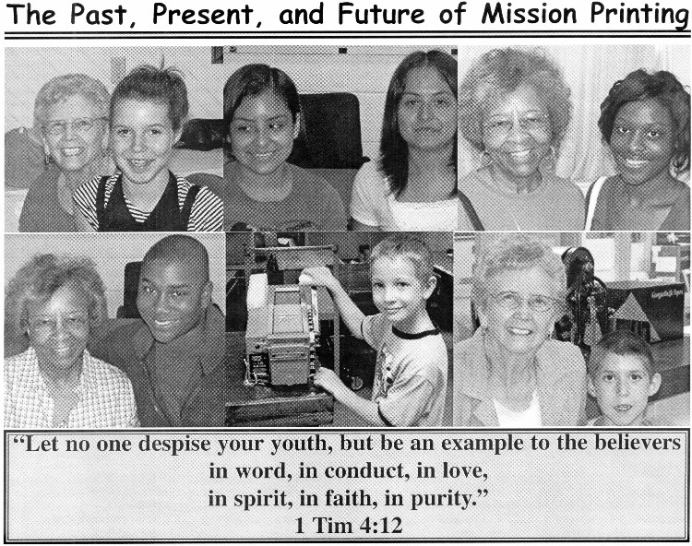
  Memorials  Adams, Bessie  Wasner, Hans & Mary  Adams, Charlyne  Craycraft, Ray & Daphne  Tarver, Cleo & Judy  Alumbaugh, Cash  Tarver, Cleo & Judy  Baggs, Thelma  Cotham, Perry  Barker, Sherman  Paul, Grady & Ruth  Batot, Nancy  Armstrong, Melvin & Evelyn  Nall, Dewayne & Linda  Ross, J.C. & Dessie  Taylor, Robert & Cathy  Wade, Myrtle  Walker, Dorris & Janie  Blades, Harold  Austin, Janet  Bradshaw, Wilma  Bradshaw, Curtis  Brooks, Robert  Brooks, Mozelle, Bob Jr. & Dorothy  Buchanan, Martha Tutor  McNeil, Dick & Barbara  Burr, Lawson  Paul, Grady & Ruth  Cann, James  Wasner, Hans & Mary  Cash, Renee  Lewellyn, Jess & Ann  Caskey, Guy  Philley, George & Edith  Conaway, Harold  Fallis, Hazel  Conner, Gene  Cotham, Perry  Cotham, Harry  Guthrie, Morris & Melba  Criswell, Jim  Cotham, Perry  Jones, Linda  Cruse, Millard  Cotham, Perry  Guthrie, Morris & Melba  Herriage, Bob & Sue  Hobby, David & Karen  Davis, Bennie  Friends @ Handley C of C  Dawdy, Bink  Dawdy, Dot  Dawdy, Faye  Dawdy, Dot  Dilks, Mary  Finley, Robert & Ouida  Lipscomb, Wayland & Mary Nell  Russwurm, Rusty & Sue  Drott, John  Tarver, Cleo & Judy  Feagans, Vera  Beaver, Raymond Family  Cook, Bonnie  Ferguson, Vivian  Taylor, Joe & Tony  Voraritskul, Joyce  Wasner, Hans & Mary  Feagley, Billie  Paul, Grady ^ Ruth  Fear, Bob  Waggoner, Frank & Wanda |  | Foshee, Christine  Atherton, Eddie & Deborah  Gray, Evelyn Cook  Johnson, Catherine  Grigg, Bob  Thornton, Charles & Norma  Guisinger, Paul  Armstrong, Melvin & Evelyn  Ross, J.C. & Dessie  Scott, Mary  Walker, Dorris & Janie  Gwinn, Irys  Wasner, Hans & Mary  Haddock, Jean  Armstrong, Melvin & Evelyn  Harris, Beverly  Cotham, Perry  Guthrie, Morris & Melba  Harris, Lydia  Lewellyn, Jess & Ann  Hill, Ruby  Young, Dub & LaVerne  Hillis, Ray  Cannefax, Ron & Helen  Kimmel, Bill & Mattie  Waggoner, Frank & Wanda  Koenig, James D.  Paul, Grady & Ruth  Lockman, Anne  Cotham, Perry  Martin, Emma  Cotham, Perry  McKeever, Naomi  Richardson, Cutah  Miller, John  Arterburn, Alma  Carroll, Mary  Moulder, Janette  Montgomery, Roger  Garner, Frances  Mouser, Alta  Braziel, Scherry  Cathey, Emery & Ann Zene  Dry, Johnnie  Pressley, Loy & Kaye  Snyder, John & Frances  Neece, Rosamond  Cotham, Perry  Needham, Wendall  Wight, John & Nancy  Parker, Pat Stinson  Anonymous  Pogue, Gary  Shipley, George & Bertie  Pogue, Stewart  Kemplin, Carl & Anna  Ramsey, Ferris & Mona Lee  Snyder, John & Frances  Reuman, Claudine  Drake, Calvin & June  Reynolds, Lauvaden  Braziel, Scherry  Reynolds, Wauthene  Braziel, Scherry  Cathey, Emery & Ann Zene  Cook, Nell  Dry, Johnnie  Pressley, Loy & Kaye  Snyder, John & Frances  Seaton, Ruby  Paul, Grady & Ruth  Seikel, Charlotte  Cotham, Perry  Singleton, Charles & Mittie  Singleton, Raymond & Charlene  Smith, Grace Tutor  McNeil, Dick & Barbara  Smith, Grady  Garner, Frances |  |  |  | Starkey, Evelyn  Guthrie, Morris & Melba  Starnes, Bill  Moulder, Janette  Stout, Mary K.  Bishop, Faye  Sweeney, Shirley  Paul, Grady & Ruth  Taylor, James Massey  Cathey, Emery & Ann Zene  Thompson, Faye  Hammons, Roxie  Martin, Ellen  Robinson, Guy & Wyvonne  Wasner, Hans & Mary  Thut, Dale  Scott, David & Linda  Vansickle, Mrs. Latha  Guthrie, Morris & Melba  Ventris, Anna  Braziel, Scherry  Cathey, Emery & Ann Zene  Cook, Nell  Dry, Johnnie  Pressley, Loy & Kaye  Snyder, John & Frances  Pam Ware  Wasner, Hans & Mary  Welch, Paula  Friends @ Handley C of C  White, Charles  Clayton, Jimmie  Wright, Kenneth  Fallis, Hazel  Lewellyn, Jess & Ann  Young, Dub & LaVerne  Wylie, Gladys  Ballew, Roy & Evelyn  Moulder, Janette  Honors  All Workers @ Mission Printing  Shipley, George & Bertie  All Workers @ Mission Printing  Walker, Dorris & Janie  “Pinky” Lewis Byers  reason: devotion towards teaching  the people of Nigeria  Murphey, Wesley & Lillian  Jessie Lee Caskey  Philley, George & Edith  Jim Corbett  reason: Father’s Day  Dollarhide Family  A.C. Massey  reason: Father’s Day  Dollarhide Family  Anniversary Honors  Vendall & Elizabeth Dollarhide (12th)  Dollarhide, Caleb, Tyler & Courtney  Bob & Billie Holloway (50th)  Dollarhide Family  Harold & Theda Walling (62nd)  Dollarhide Family  Birthday Honors  Tyler Dollarhide (7th)  Dollarhide Family  Theda Walling (81st)  Dollarhide Family  Memorial & Honors  June 1 to August 31, 2008
REMEMBER THE VALUE OF A SMILE
Eleanor Birdwell
University Church of Christ (Tyler, TX)
Mission Printing, Volunteer

It costs nothing,
but creates much.
It enriches those who receive,
without impoverishing those who give.
It happens in a flash,
and the memory of it sometimes lasts forever.
None are so rich that they can get along without it,
and none so poor but are richer for its benefits.
It creates happiness in the home,
fosters good will in a business,
and is the countersign of friends.
It is rest to the weary,
daylight to the discouraged,
sunshine to the sad,
and nature’s best antidote for trouble.

“Be glad in the Lord and rejoice, you righteous;
And shout for joy, all you upright in heart!”
Psalm 32:11

A Builder or Destroyer?
Vendall W. Dollarhide

(35) “Then Jesus went about all the cities and villages, teaching in their synagogues, preaching the gospel of the kingdom, and healing every sickness and every disease among the people. (36) But when he saw the multitudes, He was moved with compassion for them, because they were weary and scattered, like sheep having no shepherd. (37) Then He said to His disciples, ‘The harvest truly is plentiful, but the laborers are few. (38) Therefore pray the Lord of the harvest to send out laborers into His harvest.’ “  Matthew 9: 35-38  The harvest is all around us. Do you deny it? Ignore it? Or reap it?  We are called to be workers for God. Are you | choosing to be a builder or a destroyer? When we choose not to get involved in the harvest, we’re helping Satan burn the fields! By sitting idle, we are giving Satan a chance to reap a bigger crop of followers!  The Lord says that it is His harvest field. Will you actually go out and work it?  Don’t let tolerance or acceptance keep someone from hearing THE TRUTH!  “... I am the way, the truth, and the life. No one comes to the Father except through Me” (John 14:6).  STAND UP AND REAP THE HARVEST!

PLEASE NOTE
If you are not on our regular mailing list and you make a memorial donation, you will receive the issue of the newsletter in which your memorial appears. If you wish to continue receiving the newsletter, please let Mission Printing know by contacting Mary Carroll. If we do not hear from you, your name will be removed from the mailing list. We are sorry for any inconvenience that this may cause. We are attempting to reduce any expense that is not needed. Thank you for your support and prayers.
IN MEMORY OF  (Please print all information)  Mr./Mrs./Miss _______________________________  Please send notice of this gift to:  Mr./Mrs./Miss _______________________________  Mailing Address  City State Zip  Donor(s):  Mr./Mrs./Miss ________________________________  Mailing Address  City State Zip  $_________  Gift Amount |  | IN HONOR OF  (Please print all information)  Mr./Mrs./Miss ______________________________  __ Anniversary __ Birthday  __ Other _________________________________  Please send notice of this gift to:  Mr./Mrs./Miss _______________________________  Mailing Address  City State Zip  Donor(s):  Mr./Mrs./Miss ________________________________  Mailing Address  City State Zip  $_________  Gift Amount
